# Team 24 – Sprint 1 Testing Document

Sakshi Choudhary, Giorgi Khmaladze, Nick Litman, Mihir Somani, Conley Utz

User Story #11

**Test 1:** **Given that the user has filled all required fields of a listing, if the user inputs text into the “Location” field, then it is correctly stored in the database**

Purpose: To meet acceptance criteria that the location is correctly stored in the database

Steps:

1. User properly inputs data in all required fields and also inputs text into the “Location” field

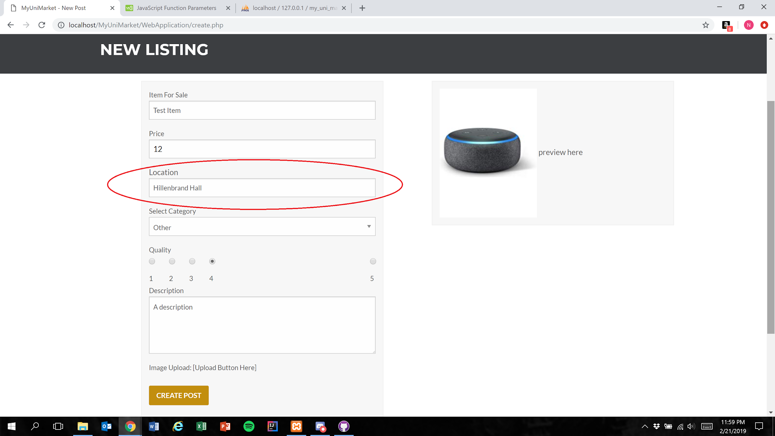

1. User presses the create post button



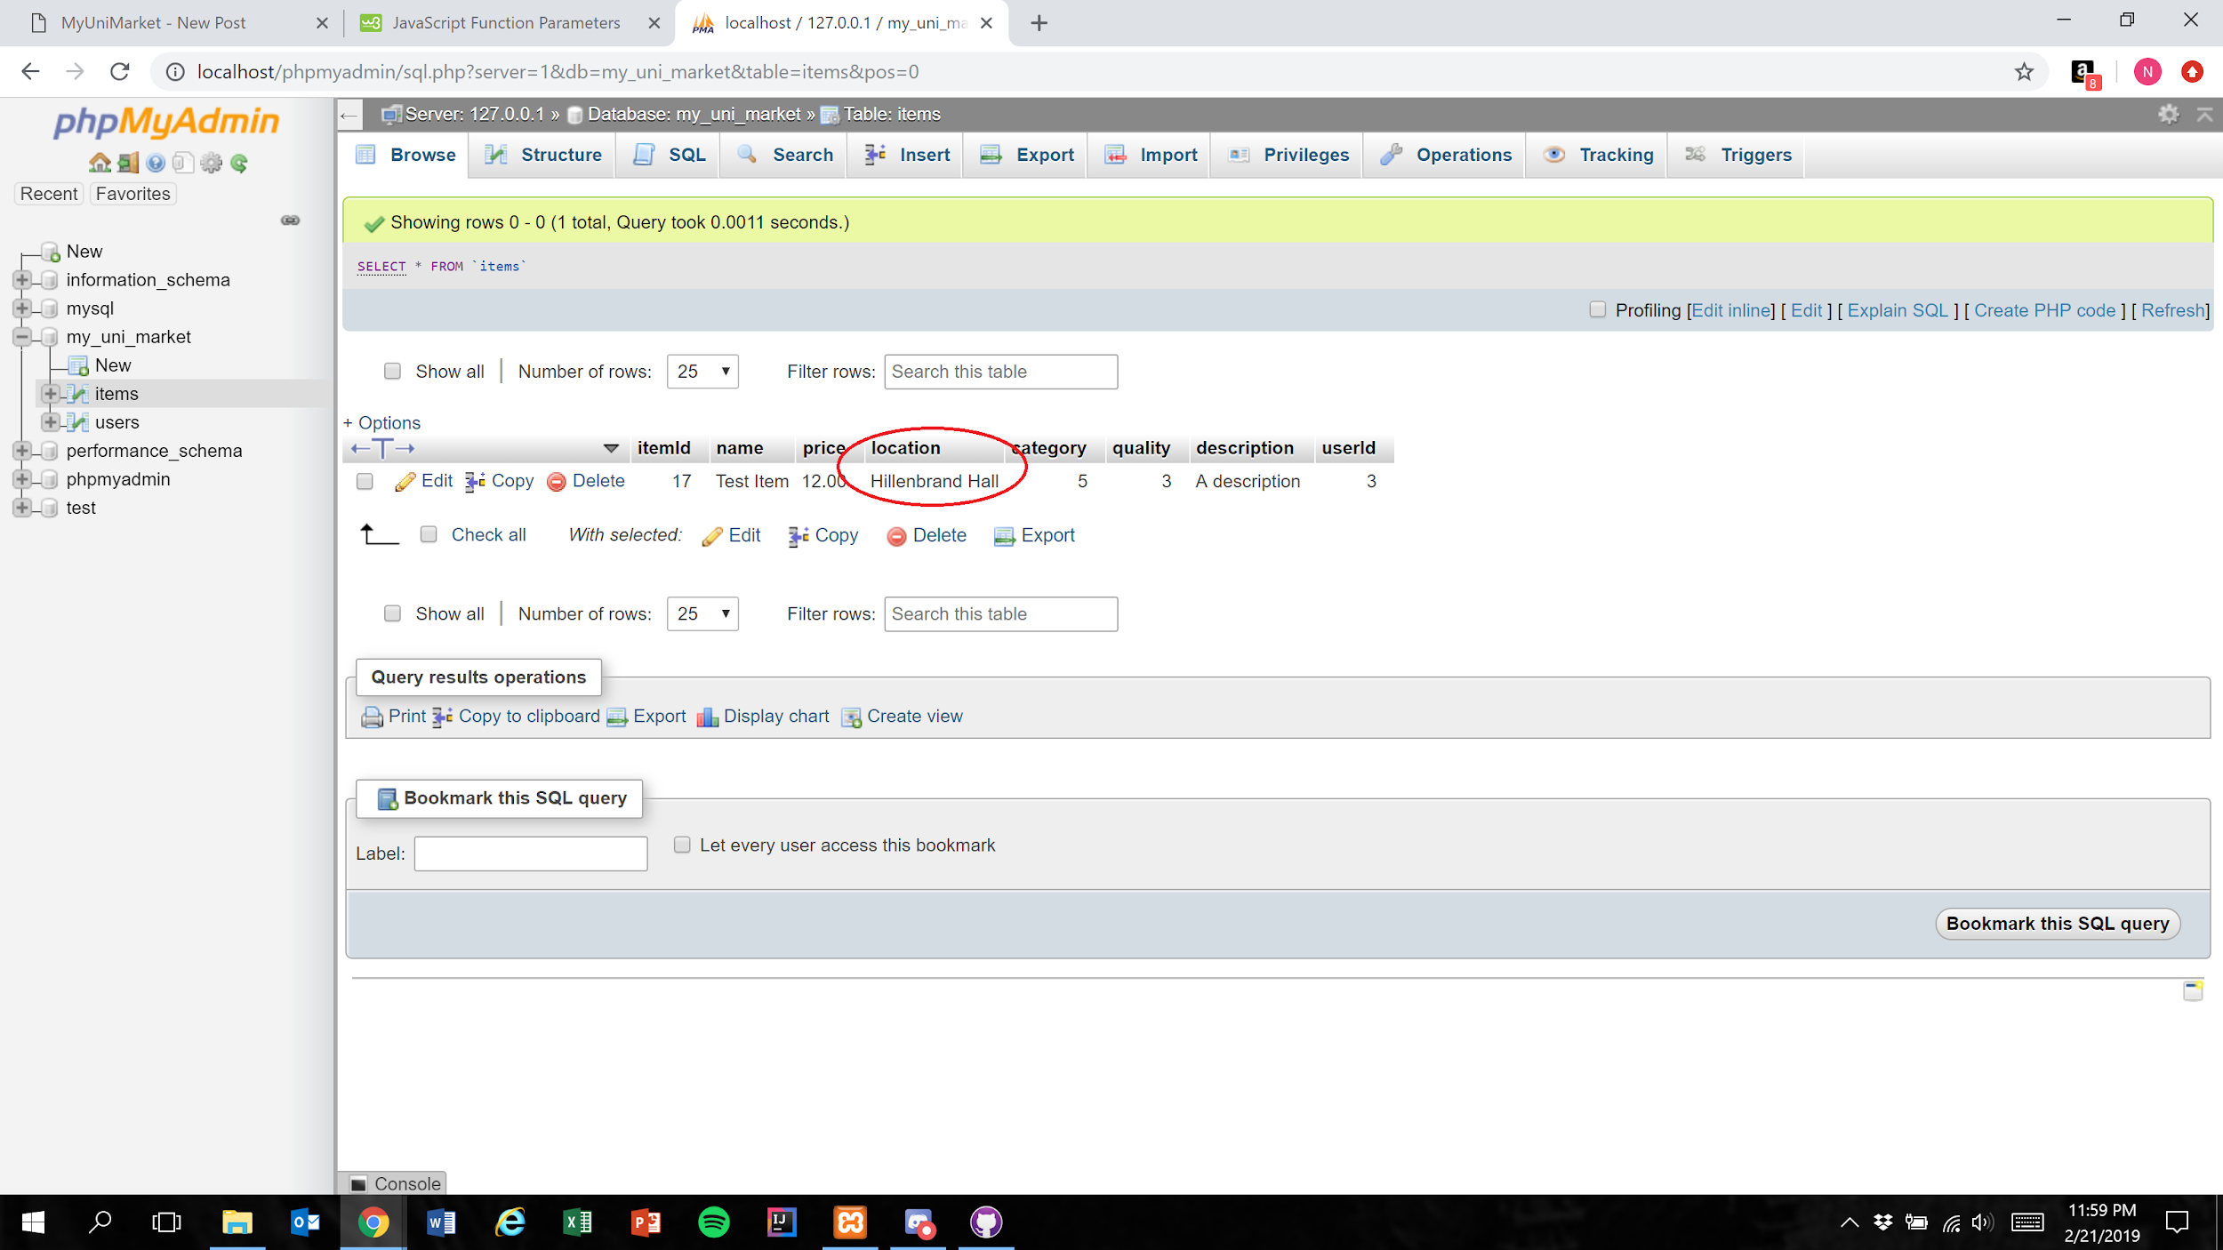

Expected Result: Text within the “Location” field is accurately represented in the database

**NOTE:** The “Location” field currently has a character limit of 100

Test Result: **PASSED**